Part one review
Exponential Functions: $y=ab^{x}$ a=initial value b=multiplier
The key to writing exponential equation is to be able to find the multiplier (b), and then be able to use it to find the start value (a) if you do not already know it.

Finding the multiplier if you a percent growth is given.
% increase (vocabulary word for this is appreciation)
Given a 7.5% appreciation, what’s the multiplier (b)?
100% +7.5% = 107.5%; therefore b=1.075
% decrease (vocabulary word for this is depreciation)?
Given a 12% depreciation what’s the multiplier (b)?
100% - 12% = 88%; therefore b= .88
Try these
Find the multiplier for the given situations
- A percent increase of 24%
- I decrease of 13%
- A 22% depreciation.
- A 4% appreciation.
Answers 1) b=1.24 2) b=.87 3) b=.78 4) b=1.04
Now apply the percent changes to build exponential equations for the given situations.

- A Ford Mustang is initially worth $35,000 and depreciates 11% annually.
- A pound of gold is worth $14,000 and appreciates 7% annually.
- A population is at 4 million and grows 4% annually.
- A bacteria population is 450,000 and is decreasing 22% daily.
Answers 5) $y=35000(.89)^{x}$ 6) $y=14000(1.07)^{x}$ 7)$y=4,000,000(1.04)^{x}$
8)$y=450000(.78)^{x}$

Build the exponential equations and solve for the indicated value.
- A 1996 Volkswagen Passat is worth $900 in 2016, it depreciates 8% a year. Write the exponential equation for the situations and calculate the expected value in 2020.
- A zombie apocalypse has occurred and there are now 23,000 zombies in Oregon in 2016. If the zombie population increases by 12 % every week write the exponential equation describing zombie growth. How many weeks will it take for the zombie population to reach 100,000?
Answers
9) $y=900(,92)^{4}=$ 10)$y=23000(1.12)^{x}$

Finding the multiplier (b) from a table.
The y column (the outputs) are being multiplied by the multiplier repeatedly, use this information to build an equation to solve for b.
Examples
Find the multiplier (b) for the following tables.
X | Y
0 | 4
1 | 7
The equation for finding b: 4b=7 and therefore b=7/4
X | Y
0 | 10
1
2 | 40
There were two multiplication of b between known values; 10bb=40, bb=4, b=2
Try these
Find the multiplier b for the following tables
11)
X | Y
0 | 5
1 | 12

12)
X | Y
0 | 3
1
2 | 48

Use the information to make a table to find the multiplier, after you have the multiplier (b) write the exponential function.
13) An exponential curve goes through (0,10) and (1,30).
14) An exponential curve goes through (1,5) and (2,25).
15) An exponential curve goes through (0,12) and has a multiplier of 7.
16) An exponential curve goes through (1,12) and has a multiplier of 3.
17) An exponential curve goes through (1,3) and (4,24).
18) An exponential curve goes through (1,7) and (3,28).

Part two review
How much of a rectangle has been removed. Given a length of 10 and a width of 4, if both the length and width are cut in half how much remains. Answer ¼ or 25% remains. Think about is, the original are was 40, and the new area is 5 x 2 = 10. 10 is one fourth of 40. The typical mistake is to not think this through and assume half the area has been removed as well.

Finding multiplier given a fractional change. It’s very easy, if a fraction goes away, the fraction that remains is the multiplier b.
Examples
2/5 of a fish population dies weekly. 5/5 -2/5 = 3/5. B=3/5
1/7 of an area decreases every minute. 7/7 -1/7 = 6/7. b= 6/7
Use the fraction remaining as a multiplier and write the exponential equation for the situation
Example: 1/8 of a 5000 square foot area goes away every hour. $y=5000({7/8)}^{x}$
Try these
19) 2/9 of 10,000 ant population dies every week.
20) 1/56 of 13 hours of daylight goes away each day.
21) ¼ of a 60 square inch rectangle goes away every minute.

Part 3 review
Fractional exponent help.

1) We will need to be able to process fractional exponents (rational exponents).
What you need to notice from the following diagram is that with the fractional exponent
- The 3 in the denominator represents instructions to find the 3rd root
- The 5 in the numerator represents instructions to raise it to the 5th power

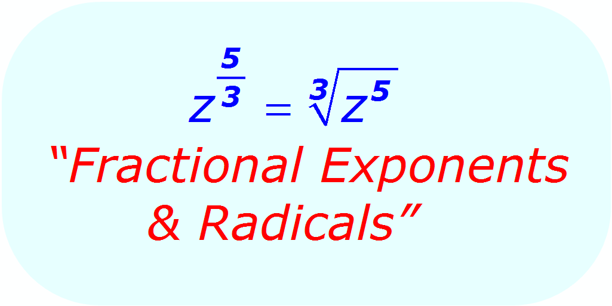

2)Here is a good image illustrating the nature of the relationship between denominator and the root. All of these at the fist power as indicated in the numerator.

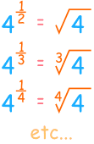

3) In example 1, notice that the typically not written square root has been translated to the denominator
In Example 2, notice it is just like the previous example.
In example 3, notice that the fractions exponent reduces as any other fraction would.

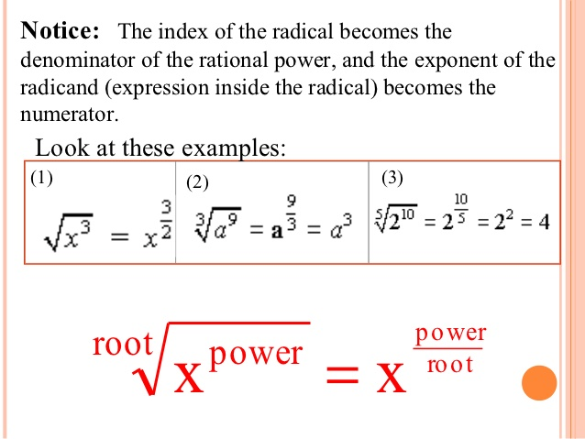

4) In simplifying fractional (rational exponents), you must choose to raise the base to the indicated power first, or the find the indicated root first. Typically one method is easier than the other, but both methods work fine.

5) In this example, if you were simplifying the fractional exponent you could have chosen to either find the 4th root of 16 (which is 2), and them raise 2 to the third power. Other students may have chosen to raise 16 to the 3rd power (which is 4096), and then found the 4th root of 4096. Clearly the first path would be easier if you did not have access to a calculator.
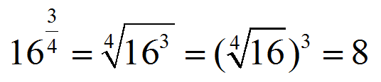

6) Here is a fractional exponent simplified that you would be asked to do without a calculator on the test. Notice the student’s choice to find the 4th root of 16 before raising 2 to the 5th power

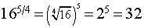

7) It doesn’t matter if the power is on the inside of the outside of the parenthesis. A is in directed to be raised to the power of m and in all cases we are directed to find the nth root of a.
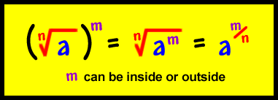

8) The specific vocabulary for each form

Try simplifying these without a calculator.
- $8^{\frac{4}{3}}$

- $9^{\frac{3}{2}}$

- ${16}^{\frac{3}{2}}$

- ${125}^{\frac{2}{3}}$

Answers 1) 16 2) 27 3) 64 4) 25

