Graph the following equations
- $x^{2}-4x-5=y$
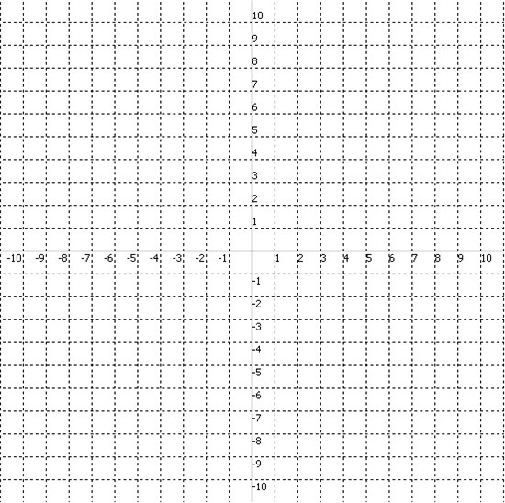
x | y | Specific point
 | 0 | x-intercept
 | 0 | x-intercept
0 |  | y-intercept
 |  | vertex

- $x^{2}-8x+12=y$

x | y | Specific point
 | 0 | x-intercept
 | 0 | x-intercept
0 |  | y-intercept
 |  | vertex

- $x^{2}+4x-5=y$
x | y | Specific point
 | 0
 | 0
0

- $x^{2}-6x+5=y$
x | y | Specific point

