Graphing a quadratic. There are many ways to graph a quadratic. This is the way we are teaching and work we want to see on your test at NSHS

Graph $x^{2}-2x-3=y$
This table will guide you through the three steps.
X | Y | Specific point
 | 0 | 1st x-intercept
 | 0 | 2nd x-intercept
0 |  | y-intercept
 |  | vertex

In each step you are starting with the original equation.
Step 1. Finding the x-intercepts
Start with the Original equation. $x^{2}-2x-3=y$
For this step you factor the equation with generic rectangles and diamonds. Here are the results after factoring.
$$x^{2}-2x-3=(x-3)(x+1)$$
Solve for the roots with the zero product property.
$$\left(x-3\right)\left(x+1\right)=0$$
From this we get the two equations x-3=0 and x+1=0, which are easily solved for x+3 and x+-1. These are x-intercepts and will be put in the guiding table and plotted on the graph
Step 2. Finding the y intercept. This is easy. At the y intercept the x value is 0, as already noted in the table. To find the y value you simply plug zero in for x in the original equation.
Start with the original equation. $x^{2}-2x-3=y$.
Enter zero in for all the x. ${(0)}^{2}-2(0)x-3=y$.
Solve for y. y=-3
So your ordered pair is (0,-3) for the y-intercept
Step 3 finding the vertex. This is similar to finding the y intercept, but the math can be more challenging. Just like the y intercept, you need an x value to plug into the original equation. In this case you use the x value that is in the middle of the 2 x-intercepts.
Start with the original equation. $x^{2}-2x-3=y$
Find the x-value in the middle of the x-intercepts. X=1
Plug this value into the original equation ${\left(1\right)}^{2}-\left(1\right)x-3=y$

Solve for y y=-4
So your ordered pair for the vertex is (1, -4)
Put these points in your table and then graph
X | Y | Specific point
3 | 0 | 1st x-intercept
-1 | 0 | 2nd x-intercept
0 | -3 | y-intercept
1 | -4 | vertex

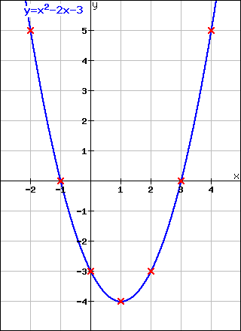

Graph the following equations
- $x^{2}-4x-5=y$
- $x^{2}-8x+12=y$
- $x^{2}+4x-5=y$
- $x^{2}-6x+5=y$

Solution to number 1

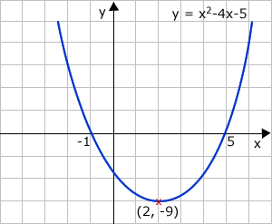

Solution to problem 2
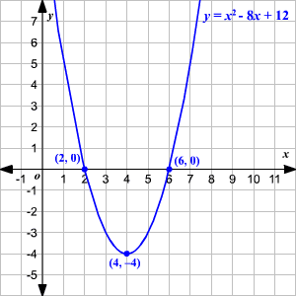

Solution to problem 3

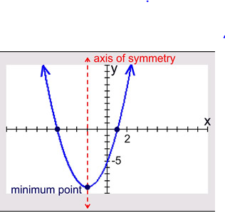
Solutions to problem 4
