The key to the story problems is getting correct equations. If you have the correct equations you can use the skills you have been developing in the Khan Academy lessons.
The perimeter of a rectangle is 34 inches. If the length is 2 inches more than twice the width, find the length and the width of the rectangle.
The perimeter of a rectangle is the sum of the four sides.
Solution:
We have two unknowns: the length and the width.
Sentence (1):''The perimeter of a rectangle is 34 inches...'' can be restated as width + width + length + length =34.
Sentence (2): ''... the length is 2 inches more than twice the width ... can be restated as the length is two times the width plus 2.
Let L = Lenth
Let W = Width
Rewrite sentences (1) and (2) in shortcut form.
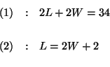
At this point use what you have learned from the Khan Academy lessons. What follows is how one person solved the system.
The Method of Substitution:
There is more than one way to do the substitution, but this works:
Step 1:
Simplify equation (1) and solve for in equation by dividing both sides by 2 and then subtracting W from both sides.
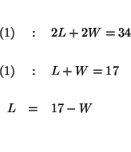
Step 2:
Substitute this value for in equation (2). This will change equation (2) to an equation with just one variable, .
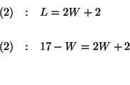
Step 3:
Solve for in the translated equation (2).
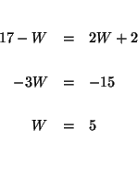

Step 4:
Substitute this value of in equation (1).
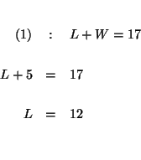

Step 5:
Check your answers by substituting the values of and in each of the original equations. If, after the substitution, the left side of the equation equals the right side of the equation, you know that your answers are correct.

