Test Topic 1
- 1-15. Finding and using a pattern is an important problem-solving skill you will use in algebra. The patterns in Diamond Problems will be used later in the course to solve other types of algebraic problems.
- Look for a pattern in the first three diamonds below. For the fourth diamond, explain how you could find the missing numbers (?) if you know the two numbers (#).
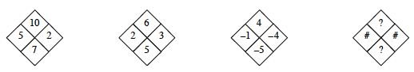
Copy the Diamond Problems below onto your paper. Then use the pattern you discovered to complete each one.
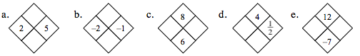
Solution to test topic 1
What do you do to each of the # numbers to get to the ? numbers?
See the diamonds below. In the example diamonds, notice how one row added
together equals the bottom number, while that row multiplied equals the top number. 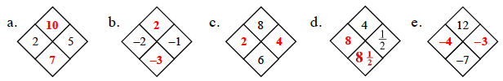
Test Topic 2
1-28. Solve the equations below for x and check your solutions.
  - −3 + 2x = −x + 6

  - 5 − 3x = x + 1

Solution to test topic 2

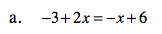

Solution to part a. Add 3 to both sides.
−3 + 2x = −x + 6
+3 +3
2x = −x + 9
Add x to both sides.
2x = −x + 9
+x +x
3x = 9
Divide both sides by 3.
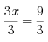
X=3
A verification is needed for full credit. To verify you need to substitute the identified solution into the original equation and simplify to a true statement. For example 3 substituted into the original equation would be
-3 + 2(3) = -3 + 6 which simplified to the true statement 3=3.

Test topic three
Graphing a quadratic and use vocabulary to describe it
Given Y = x²-2x-3 graph make a table over the interval x=-2 to x=4, graph it, and use vocabulary to describe
Test Topic three solution
x | y
-2 | 5
-1 | 0
0 | -3
1 | -4
2 | -3
3 | 0
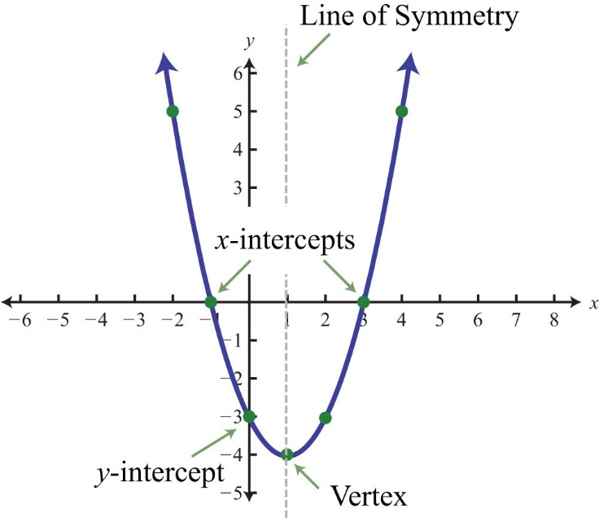
Identify
- Domain. All x values
- Range. All y values greater than -4
- Axis of symmetry. X=1
- X-intercepts. (-1,0), (3,0)
- Y-intercepts (0,-3)
- Shape. Parabola
- Minimum. (1,-4)
- Vertex.(1,-4)
- Opening. Up
- Increasing. From x=0 to positive infinity.
- Decreasing. From negative infinity to x=0
- Function. Yes.
Test Topic four
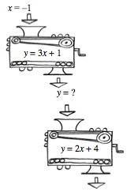
Given the above function work the input through the top function and have the output go through the second function.
Test topic four answer
Answer. The value coming out the second function will be zero.
You will also be asked about domain and range restrictions (input and output restrictions).

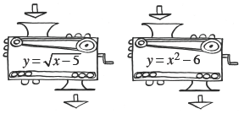
For example there is a restriction on the input for the first function shown. You cannot take the square root of a negative number, therefore x=5 is the smallest allowable input anything less than x=5 would require the square root of a negative number.
The second function has no restriction in input, but has one with the output. The smallest value of any x² will be zero, so zero minus 6 is the smallest output. -6.

Algebra notes
X³ = xxx
Absolute value bars ask how far an item is from zero. For example $\left|-6\right|=6$

