Practice test for ch5
Part one. Determine if a given value can be a value of a term of a term in an arithmetic sequence in the t(n) notation.
Why we have this problem. Term numbers can only be whole numbers. If you are given a possible term value to consider. You should be able to plug the value into an arithmetic equation and solve for an term (n) that is a whole number

Determine if 361 can be a term in the sequences that the following arithmetic equations represent. If so what term number is it
Example
- T(n) = 3n + 25 b) T(n)=7(n) + 20 c) t(n) = 4(n-1) + 12
361 = 3n + 25
-25 -25
336 = 3n
112 = n, So we can say that
T(112) = 336 which means that the
112th term in the sequence has a value
of 336.

Because when you got inserted 361 for T(n), and then solved for the term number (n) you got a whole number, 336 is a valid term value, further we know that it will be the 112th term in the sequence.

Try b and c

Part two
Given a sequence, you should be able to determine the generator (what makes the pattern work), write the recursive equation, and the explicit equation.
Example
- 4, 16, 64, … generator (multiply by 4), Recursive equation t(n) = t(n-1)(4) Explicit equation $t\left(n\right)=(4)(4)^{n-1}$

- 7, 14, 28, … generator (multiply by 2), recursive equation t(n)= t(n-1)(2) Explicit equation
$t\left(n\right)=(7){(2)}^{n-1}$
- 13,15,17… generator (adding 2), recursive equation t(n) = t(n-1)+2 Explicit equation
  - $t\left(n\right)=13+2(n-1)$

- 8, 12.5, 17, …. Generator___________ recursive equation__________________
Explicit equation_____________

- 31, 25, 19, … Generator________________ recursive equation________________
Explicit equation__________________

- 12, 36, 108, ... Generator______________ Recursive equation_________________
Explicit equation__________________

- 125, 25, 5, … generator_____________ recursive equation_________________
Explicit equation___________________

Part 3 Given a table or a graph determine if it is an arithmetic sequence, geometric sequence or neither.

- Example
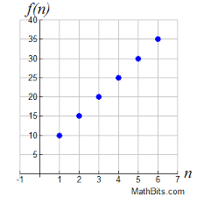

The sequence is 10, 15, 20, …
Therefore I know it is Arithmetic because the generator is adding 5 repeatedly

b)

The sequence is ___________________
Therefore I know the sequence is_________________ because the generator is _____________

- Example
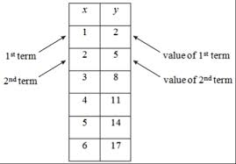

The sequence is 2, 5, 8 ….
Therefore I know the sequence is arithmetic because the generator is adding 3

d)
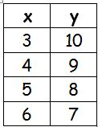

The sequence is ___________________
The generator is ________________, therefore you I know the sequence is __________________

e)Example
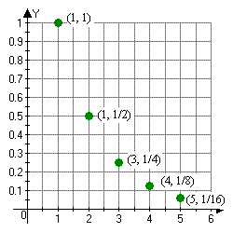

The sequence goes 1, ½, ¼, 1/8,
The generator is dividing by 2 repeatedly, since division is a type of multiplication this is a geometric sequence

f)

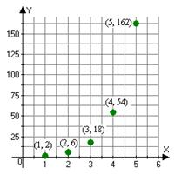
The sequence goes________________
The generator is ___________, therefore I know it is ______________sequence

g)Example
N | T(n)
1 | 3
2 | 12
3 | 48
4 | 192
The sequence goes 3, 12, 48, 192, …
The generator is multiplying by 4, therefore I know this is a geometric table

H)
n | T(n)
1 | 5
2 | 15
3 | 45
4 | 135

The sequence goes _____________
The generator is _________________, therefore this is a ____________sequence.

