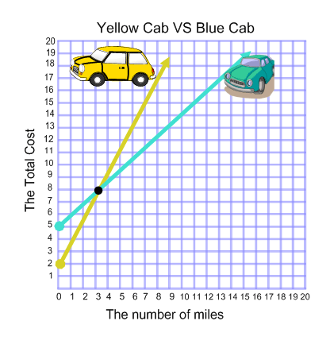

Systems Graph analysis basics.
- What is the solution? The answer is the point where the lines cross. Answer (3,8)
- What does the solution mean? The answer is an explanation of the previous ordered pair, Answer, After 3 miles both cabs will charge $8 dollars.

